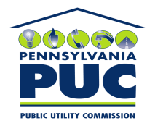 | COMMONWEALTH OF PENNSYLVANIA  PENNSYLVANIA PUBLIC UTILITY COMMISSION  P.O. BOX 3265, HARRISBURG, PA 17105-3265 | IN REPLY PLEASE REFER TO OUR FILE

July 19, 2010
U-2010-2182701

VERNON L BRACEY
THE YORK WATER COMPANY
130 EAST MARKET STREET
PO BOX 15089
YORK PA 17405-7089

Agreement dated June 10, 2010 between The York Water Company and Jacobus Borough Sewer Authority relative with the termination of water service for non-payment of sewer bills.

To Whom It May Concern:

We enclose herewith the original and one (1) copy of certificate of filing issued by this Commission in accordance with Section 507 of the Public Utility Code, 66 Pa. C.S. §507.

You should serve the enclosed copy of this certificate upon the Borough of Jacobus.

Very truly yours,

Rosemary Chiavetta
Secretary

mh
encls.
cert.mail

